MSIS 638

Case 3.4a

Jia Liang Ma

1. Consider the transportation problem discussed in Chapter 3.
   * How can you make this problem infeasible? Write the whole formulation of the infeasible problem.

If the demand larger than the supply, then the problem become infeasible.

For example, the demand in Marshalls is 550, also equal to the supply at the Case 3.3. We change the number of demands into 580.

xTM + xWM ≤ 580

* + Use Excel to check that the revised problem is indeed infeasible.

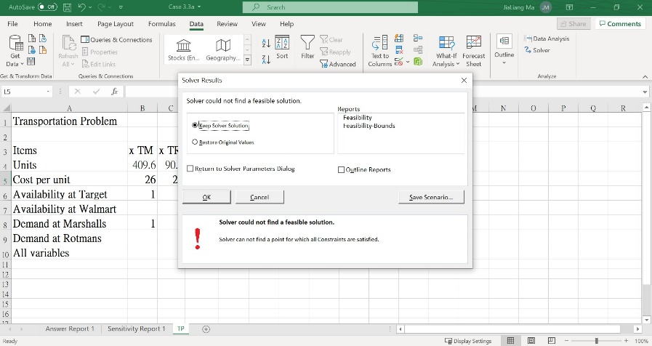

* + What happens when you click the Solve button in Solver attempting to solve an infeasible problem? What message you get?

After typing a larger demand, receiving an error message from the solver.

1. Consider the product mix problem discussed in Chapter 3.
   * How can you make this problem infeasible? Write the whole formulation of the infeasible problem.
2. Make the constraints more restrictive. For example, changing the bitterness requirement from 7 to 9 will cause the error in solver for finding the optimal solution.
   * Use Excel to check that the revised problem is indeed infeasible.

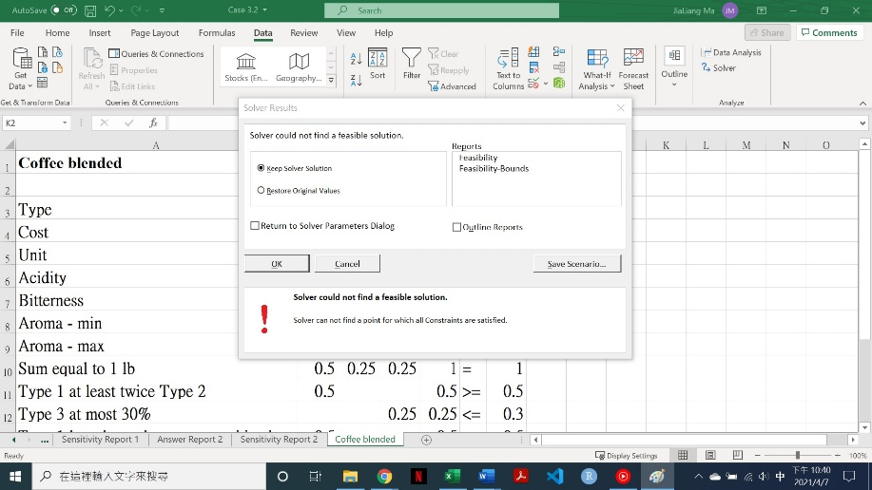

1. Consider the product mix problem discussed in Chapter 3.
   * How can you make this problem unbounded? Write the whole formulation of the unbounded problem.

Make the constraints with no mutual limits, then the unbounded situation happened. It is possible that the objective function increases or decreases with no bound.

For example, if the objective function is 4x1 - 3x2 ≥ 20

The constraints are x1 ≥ 8, x2 ≤ 5, x1 n x2 ≥ 0.

Then under this situation it will generate the unbounded situation.

* + Use Excel to check that the revised problem is indeed unbounded.
  + What happens when you click the Solve button in Solver attempting to solve an unbounded problem? What message you get?

It will generate an error while pressing the solve button.

1. Write an LP formulation that has multiple optimal solutions. Show that it has multiple optimal solutions and list three optimal solutions.

Max 9x1 + 12x2

3x1 + 4x2 ≤ 18

x1, x2 ≥ 0

So, 9x1 + 12x2 ≤ 54

1. x1=1, x2=3

2. x1=3, x2=2

3. x1=3, x2=1